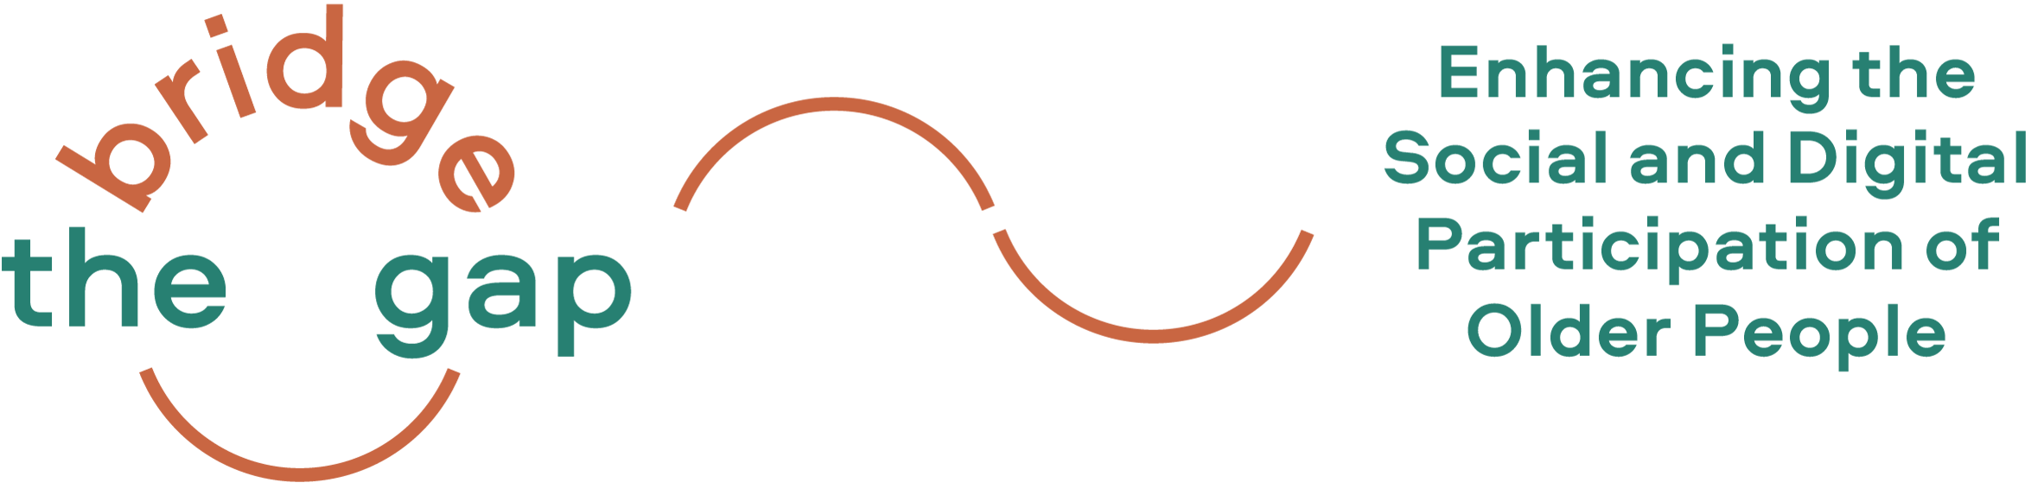

Welcome to our Updates from the Bridge the Gap! Project

Project News
In autumn 2020 we started with our Erasmus+ project Bridge the Gap! (realized until September 2022) in which we aim to find creative and sustainable ways to enable older people to live autonomously and to shape their living environments in a way that sustains the independence as well as the social and digital participation of older citizens.
In the past months we have been busy preparing and organising our trainings and workshop series in 5 different countries (Austria, Germany, Italy, Lithuania and the Netherlands). The aim of the trainings is to test and further develop the previously developed curriculum, methods and tools. Throughout the training sessions we have met enthusiastic and inspiring older learners and gained valuable insights in regards to their digital participation, needs and preferences!
Our training sessions in all five countries were adapted to the interests and prior experiences of our participants with digital tools, age-friendly environments and volunteering.  In the Netherlands, twenty-four older adults from The Hague and Gouda participated with much enthusiasm in workshop sequences of six meetings and chose to focus on age-friendly themes including outdoor spaces, mobility and social participation and digital tools such as QR-Codes and social media.  In Germany, the training was tested in Bad Vilbel, where participants deepened their knowledge on digital applications supporting age-friendly initiatives such as MS Publisher and image databases. In their work on a local project, they focused on expanding the smartphone consultation hours to more neighbourhoods.  In Lithuania, the training took place in two public libraries in Kaunas with 16 older citizens. Participants among other things practiced with a transport App to navigate to a smart home technology appliance store. In their work on a local project, they practiced making and uploading photos and videos into the digital map of Sanciai community.  In Italy the December training sessions have taken place at and have been jointly organized by Rome's Giorgio Perlasca Social Center. 23 participants have explored and practised the potentials of digital tools and social media. The learning and skill exchanges have been specifically finalized towards proposals to improve, in an age-friendly perspective, services for and with older citizens in the Municipality in which the Center is active.  In Austria, the training series kicked off with a neighbourhood walk and 60+ check where participants assessed the age-friendliness of a neighbourhood. Further meetings were dedicated to deepen digital skills, including WordPress and QR Codes.  To find out more on our project activities and outcomes, please have a look at the Bridge the Gap! website: https://bridgethegap-project.eu/news/ | 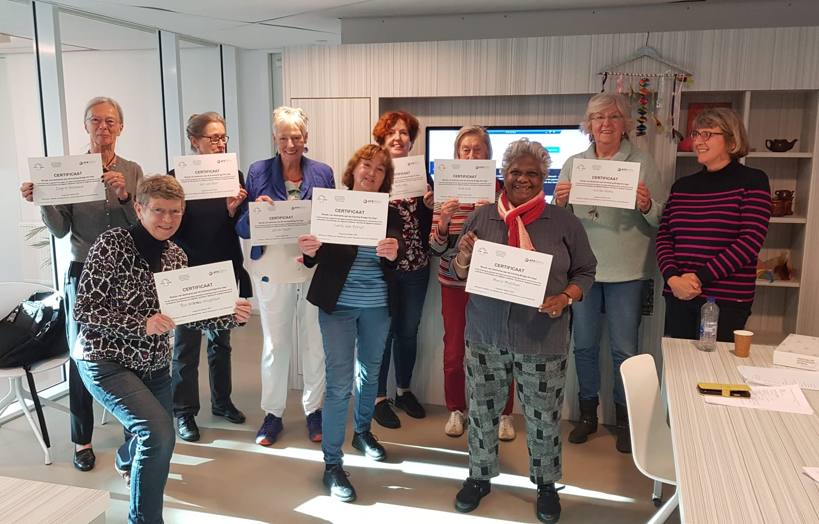  ©AFEdemy  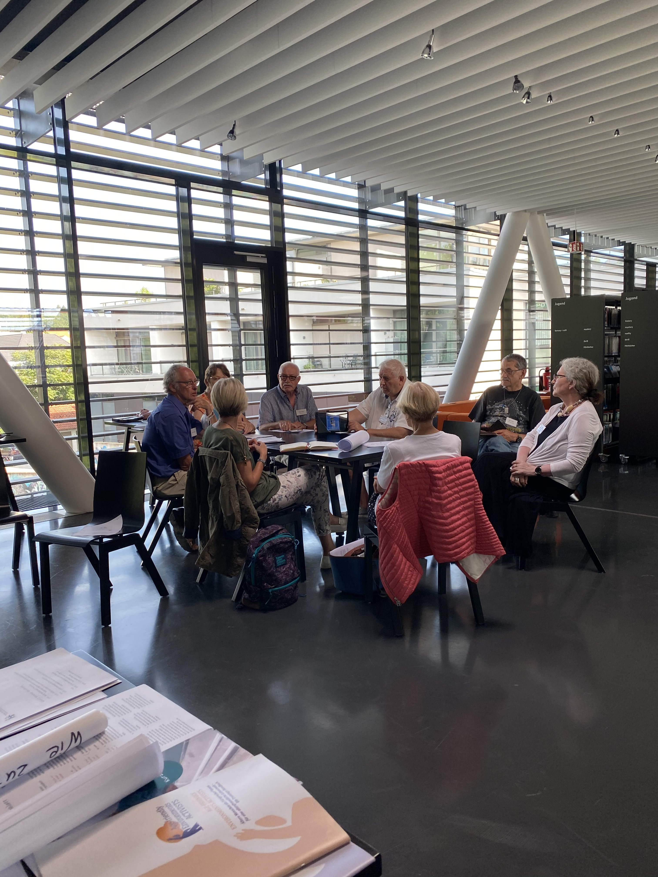  © ISIS GmbH  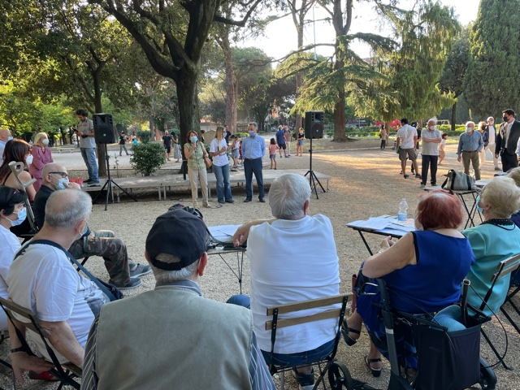  © Angela Pagano, Lunaria  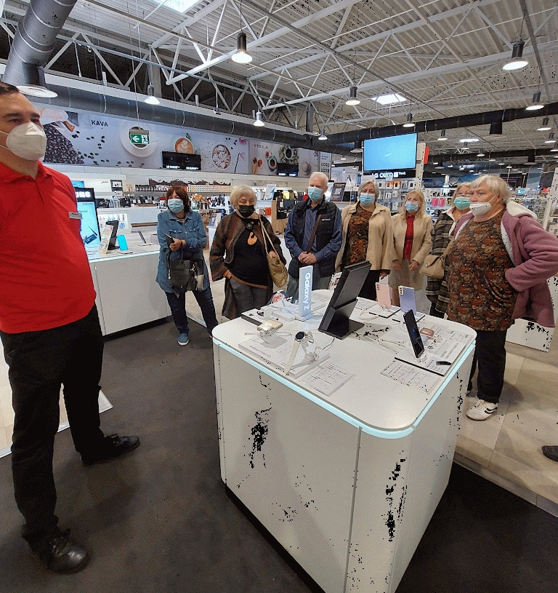  © Edita Šatienė  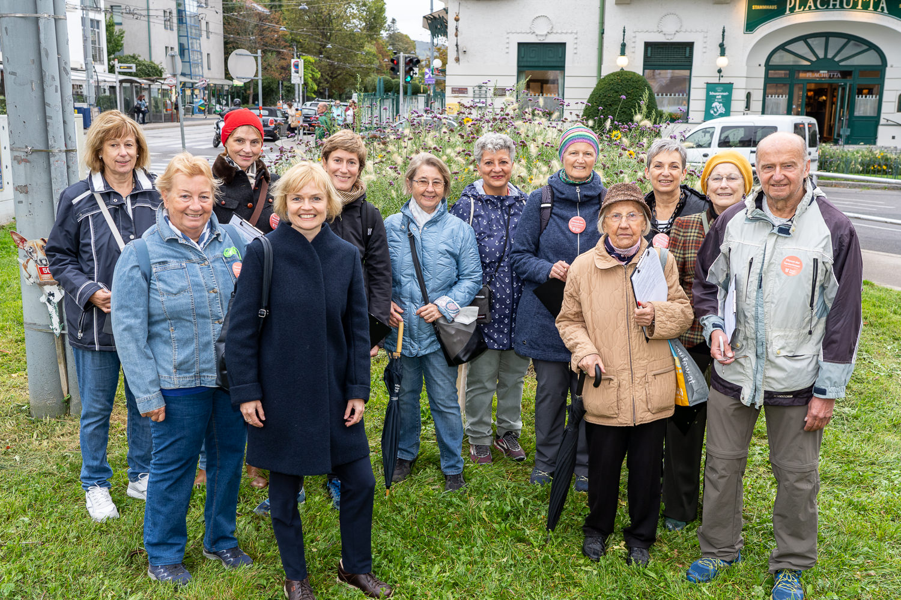  © Voglhuber

Next step(s) – Stay tuned!

Learning from our training experiences and developing the Training Kit!
We are currently developing our Training Kit which will support and motivate trainers (including adult educators, community developers, volunteers in organisations working for/with older persons) to carry out trainings or to use selected tools in their training provisions.
The Training Kit will provide useful and practical training methods, as well as tips and tricks on how to support team-work and foster mutual learning.

Please feel free to contact us if you require any further information or if you wish to share your experiences and ideas!

Best wishes,

The Bridge the Gap! partnership

In terms of privacy policy …
We would like to continue to provide you with up-to-date information about our projects and are glad to do so if you continue to subscribe to our newsletter, however, we also remind you that you can unsubscribe from this distribution list at any moment by clicking on "unsubscribe from this list" (see below). Your personal data will then be deleted from our mailing list. If you wish to receive again Bridge the Gap! newsletter, you will need to subscribe again and enter your personal data on www.dreamlike-neighbourhood.eu. In short, we assure you that we handle your personal data with the utmost attention and care. If you want to know more about it, here you will find our privacy policy.

The European Commission's support for the production of this publication does not constitute an endorsement of the contents, which reflect the views only of the authors, and the Commission cannot be held responsible for any use which may be made of the information contained therein.

